Questions:

- Write a class to have at least 3 data members along with their getter and setter methods. Create 3 different instances of this class and print them.
[0.5 hrs]

public class ProjectTracker {

private String projectName;
private String projectOwner;
private Integer estimatedHours;

public String getProjectName() {
return projectName;
}

public void setProjectName(String projectName) {
this.projectName = projectName;
}

public String getProjectOwner() {
return projectOwner;
}

public void setProjectOwner(String projectOwner) {
this.projectOwner = projectOwner;
}

public Integer getEstimatedHours() {
return estimatedHours;
}

public void setEstimatedHours(Integer estimatedHours) {
this.estimatedHours = estimatedHours;
}

public String displayDetails() {
return 'Project Name: ' + projectName +
', Owner: ' + projectOwner +
', Estimated Hours: ' + estimatedHours;
}
}

Anonymous window
ProjectTracker project1 = new ProjectTracker();
project1.setProjectName('Customer Portal Upgrade');
project1.setProjectOwner('Harshvardhan');
project1.setEstimatedHours(120);

ProjectTracker project2 = new ProjectTracker();
project2.setProjectName('Lead Automation');
project2.setProjectOwner('Aditi');
project2.setEstimatedHours(85);

ProjectTracker project3 = new ProjectTracker();
project3.setProjectName('Case Management Enhancement');
project3.setProjectOwner('Rahul');
project3.setEstimatedHours(150);

System.debug(project1.displayDetails());
System.debug(project2.displayDetails());
System.debug(project3.displayDetails());

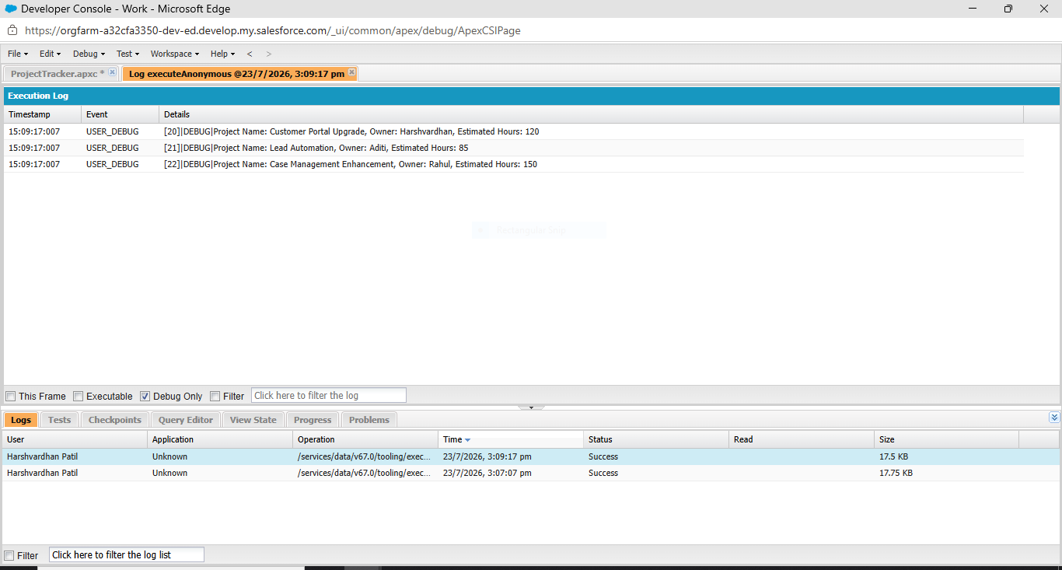

2. Write a program to count occurrences of each digit in a number, print the output in ascending order as displayed below:
E.g. Enter the number: 41123
Output:
Occurance of 1 : 2
Occurance of 2 : 1
Occurance of 3 : 1
Occurance of 4 : 1
Please note that the digits which were not part of the input number have not been displayed in output with count zero.
[1 hr]

public class DigitFrequencyTracker {

private String inputNumber;

public DigitFrequencyTracker(String numberValue) {
inputNumber = numberValue;
}

public void showDigitFrequency() {

Map<String, Integer> counter = new Map<String, Integer>();

for(Integer i = 0; i < inputNumber.length(); i++) {

String currentDigit = inputNumber.substring(i, i + 1);

if(counter.containsKey(currentDigit)) {
counter.put(currentDigit,
counter.get(currentDigit) + 1);
} else {
counter.put(currentDigit, 1);
}
}

for(Integer digit = 0; digit <= 9; digit++) {

String digitValue = String.valueOf(digit);

if(counter.containsKey(digitValue)) {
System.debug('Occurrence of ' + digitValue +
' : ' + counter.get(digitValue));
}
}
}
}

Anonymous Apex
DigitFrequencyTracker frequencyReport =
new DigitFrequencyTracker('55846699');

frequencyReport.showDigitFrequency();

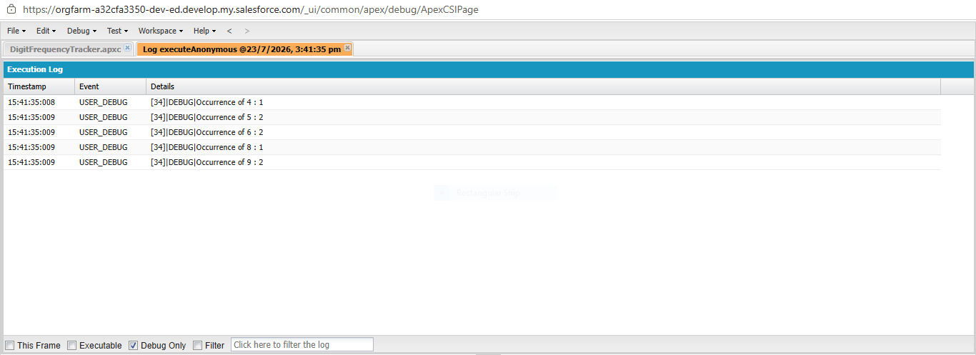

3. Write a base class “Shape”. Derive two classes from it “Rectangle” and “Triangle”. Both derived classes should calculate area by using single method “calculateArea” which should be declared in base class and overridden in derived classes.
[0.5 hrs]
public virtual class Shape {

public virtual Decimal calculateArea() {
return 0;
}
}

public class Rectangle extends Shape {

private Decimal length;
private Decimal width;

public Rectangle(Decimal l, Decimal w) {
length = l;
width = w;
}

public override Decimal calculateArea() {
return length * width;
}
}

public class Triangle extends Shape {

private Decimal baseValue;
private Decimal height;

public Triangle(Decimal b, Decimal h) {
baseValue = b;
height = h;
}

public override Decimal calculateArea() {
return (baseValue * height) / 2;
}
}

Anonymous Apex
Shape rectObj = new Rectangle(12, 5);
System.debug('Rectangle Area : ' + rectObj.calculateArea());

Shape triObj = new Triangle(10, 8);
System.debug('Triangle Area : ' + triObj.calculateArea());

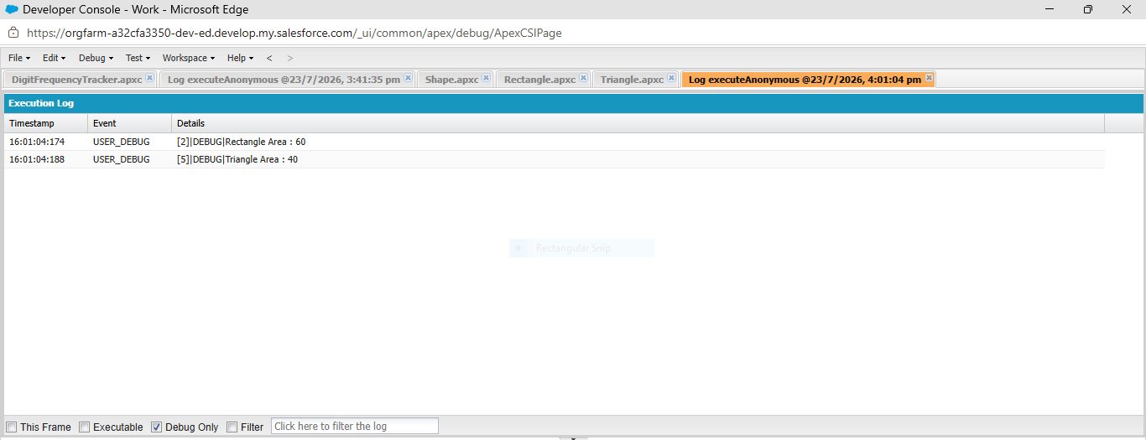

4. Consider scenario of a bank and assume basic classes like customer, account, employees, etc. Keep in mind some of the points like -
○ An account can be of two types saving or current
○ Employees can also have account in the bank
○ Banks can give loan to customers
○ Customers can deposit money in their accounts

○ Perform the following actions:
  - Create 2 customer objects, one having saving account and another having current account
  - Accept deposit from both type of customers and update their balance. Also, display balance in their accounts
  - When an account is opened, it must have minimum of Rs. 1000 balance. At any point in time, this minimum balance should not be less than 1000.
  - Create a loan object for any of the customer and calculate compound interest.

[2.5 hrs]

public class Account {

private String accountType;
private Decimal balance;

public Account(String accountType, Decimal openingBalance) {

if(openingBalance < 1000) {
balance = 1000;
} else {
balance = openingBalance;
}

this.accountType = accountType;
}

public void deposit(Decimal amount) {
balance = balance + amount;
}

public Decimal getBalance() {
return balance;
}

public String getAccountType() {
return accountType;
}
}

public class Customer {

private String customerName;
private Account customerAccount;

public Customer(String name, Account acc) {
customerName = name;
customerAccount = acc;
}

public void depositMoney(Decimal amount) {
customerAccount.deposit(amount);
}

public void displayBalance() {

System.debug('Customer : ' + customerName);
System.debug('Account Type : ' + customerAccount.getAccountType());
System.debug('Balance : Rs. ' + customerAccount.getBalance());
}

public String getCustomerName() {
return customerName;
}
}

public class Loan {

private Customer customer;
private Decimal principal;
private Decimal rate;
private Integer years;

public Loan(Customer customer,
Decimal principal,
Decimal rate,
Integer years) {

this.customer = customer;
this.principal = principal;
this.rate = rate;
this.years = years;
}

public void calculateCompoundInterest() {

Decimal amount = principal;

for(Integer i = 1; i <= years; i++) {
amount = amount * (1 + rate / 100);
}

Decimal compoundInterest = amount - principal;

System.debug('Loan Customer : ' + customer.getCustomerName());
System.debug('Principal Amount : Rs. ' + principal);
System.debug('Compound Interest : Rs. ' + compoundInterest);
System.debug('Total Amount : Rs. ' + amount);
}
}

Anonymous Apex

Account savingAcc = new Account('Saving', 5000);
Customer customer1 = new Customer('Harshvardhan', savingAcc);

Account currentAcc = new Account('Current', 3000);
Customer customer2 = new Customer('Rohit', currentAcc);

customer1.depositMoney(2000);
customer2.depositMoney(1500);

customer1.displayBalance();
customer2.displayBalance();

Loan loan1 = new Loan(customer1, 100000, 10, 2);
loan1.calculateCompoundInterest();

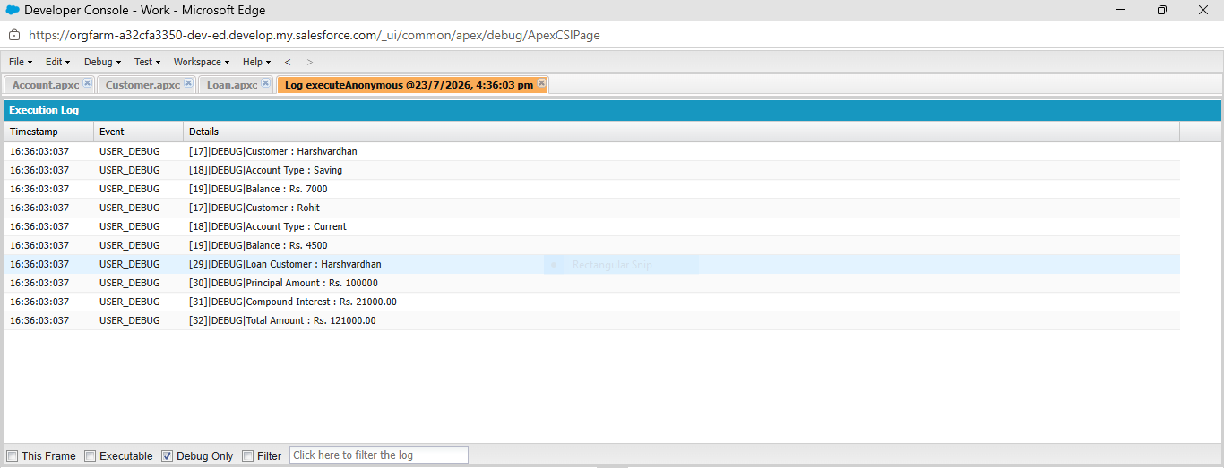

5. Write a program that displays entered number in words.
e.g. input: 50213
Output: fifty thousand two hundred thirteen
Min number: 0
Max number: 99,99,999
Out of scope: -ve numbers

[1 hr]
public class NumberConverter {

private static final List<String> WORDS_0_TO_19 = new List<String>{
'', 'One', 'Two', 'Three', 'Four', 'Five',
'Six', 'Seven', 'Eight', 'Nine', 'Ten',
'Eleven', 'Twelve', 'Thirteen', 'Fourteen',
'Fifteen', 'Sixteen', 'Seventeen', 'Eighteen',
'Nineteen'
};

private static final List<String> TENS_WORDS = new List<String>{
'', '', 'Twenty', 'Thirty', 'Forty',
'Fifty', 'Sixty', 'Seventy', 'Eighty', 'Ninety'
};

public static String convertNumber(Integer numberValue) {

if (numberValue == 0) {
return 'Zero';
}

String output = '';

Integer lakhPart = numberValue / 100000;
numberValue = Math.mod(numberValue, 100000);

Integer thousandPart = numberValue / 1000;
numberValue = Math.mod(numberValue, 1000);

Integer hundredPart = numberValue / 100;
numberValue = Math.mod(numberValue, 100);

if (lakhPart > 0) {
output += getTwoDigitWord(lakhPart) + ' Lakh ';
}

if (thousandPart > 0) {
output += getTwoDigitWord(thousandPart) + ' Thousand ';
}

if (hundredPart > 0) {
output += WORDS_0_TO_19[hundredPart] + ' Hundred ';
}

if (numberValue > 0) {
output += getTwoDigitWord(numberValue);
}

return output.trim();
}

private static String getTwoDigitWord(Integer value) {

if (value < 20) {
return WORDS_0_TO_19[value];
}

Integer tensPart = value / 10;
Integer unitsPart = Math.mod(value, 10);

String result = TENS_WORDS[tensPart];

if (unitsPart > 0) {
result += ' ' + WORDS_0_TO_19[unitsPart];
}

return result;
}
}

Anonymous Window
System.debug(NumberConverter.convertNumber(50213));
System.debug(NumberConverter.convertNumber(9999999));
System.debug(NumberConverter.convertNumber(1234567));

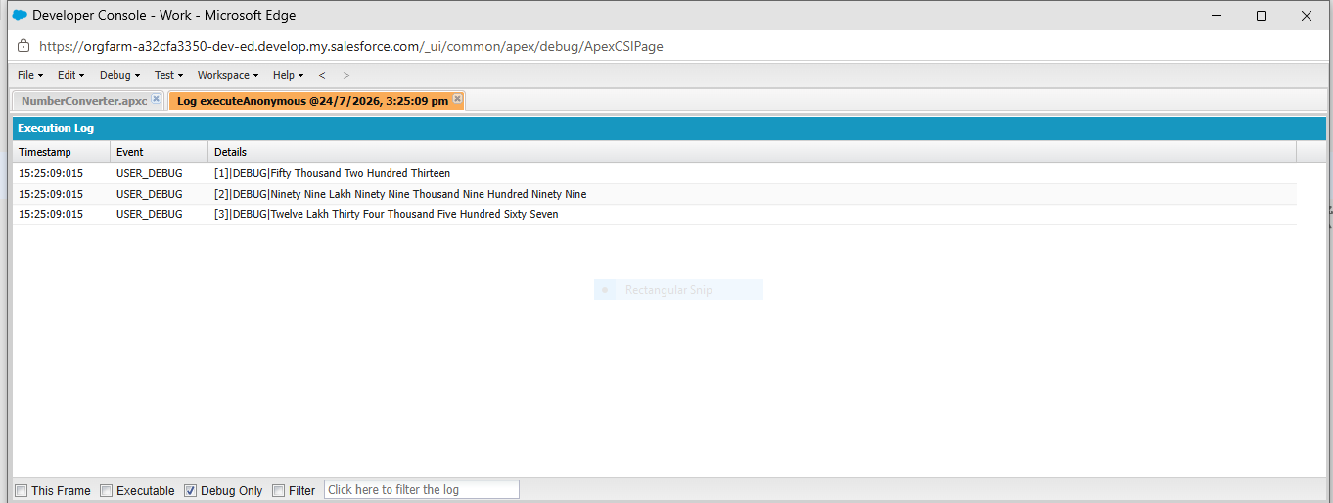

6. Come up with a scenario(use case) where interface can be used. Describe and justify the scenario. Provide implementation to support your scenario.
[0.5 hrs]
A practical scenario where an interface is useful is in a payment processing system for an e-commerce application.

Scenario: Online Shopping Payment System
An interface in Java is used to define a set of methods that a class must implement. It provides abstraction by specifying what a class should do, not how it should do it.
Interfaces are useful when multiple classes need to perform the same action in different ways.
In an online shopping application, customers can choose different payment methods such as:
- Credit Card
- UPI
- PayPal
Although the payment methods are different, they all have one common task: making a payment.
Instead of creating separate unrelated classes, we can create a PaymentMethod interface containing a common method pay(). Every payment class will implement this interface and provide its own version of the pay() method.

Advantages
- Provides a common structure for all payment methods.
- Makes the code easy to understand and maintain.
- Allows new payment methods to be added easily.
- Supports code re usability and flexibility.
// Interface
interface PaymentMethod {
void pay();
}

// Credit Card class
class CreditCard implements PaymentMethod {
public void pay() {
System.out.println("Payment made using Credit Card");
}
}

// UPI class
class UPI implements PaymentMethod {
public void pay() {
System.out.println("Payment made using UPI");
}
}

// Main class
public class Main {
public static void main(String[] args) {

PaymentMethod p1 = new CreditCard();
PaymentMethod p2 = new UPI();

p1.pay();
p2.pay();
}
}

- Complete the following Trailhead:
Object Oriented Programming for Admins
https://trailhead.salesforce.com/content/learn/modules/object-oriented-programming-for-admins
[0.6 hrs]
